Weight Bench, Abdominal Training Workout Gliding Bench Exercise Gym Training Fitness Incline Adjustable Foldable Dumbbell Barbell Workout Bench - Compact Design
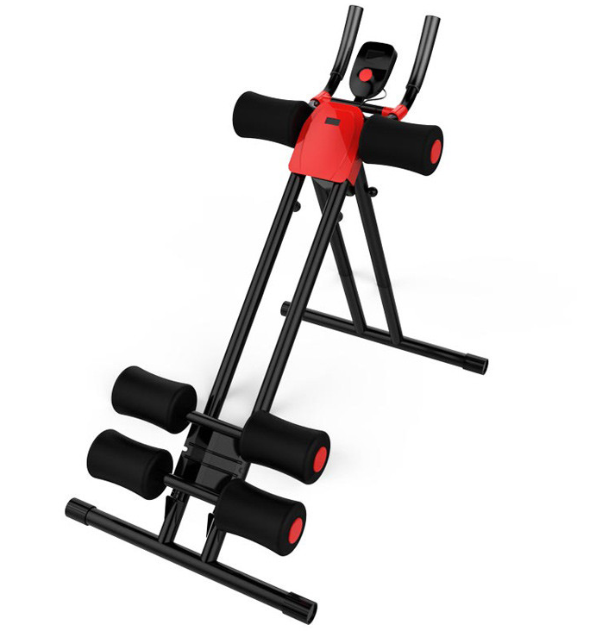

About this item
- Exercise Bench, Abdominal Training Workout Gliding Bench, Compact Design, Home and Gym Workout Bench - Ab Core Trainer Bench
- TRAINER AB Core / Sit - Up TRAINING | This Core & Abdominal Trainers is designed to train the upper body through exercises such as sit-ups, push-ups and leg lifts to shape the lines of arms, abdomen, waist, core and legs, compant folable design for home or gym use.
- STURDY HEAVY DUTY IRON MATERIAL | The ab machine is crafted with sturdy iron, which is durable for long-lasting use. The Solid Iron frame comes with large weight capacity of 220lbs. Meanwhile, sturdy material leaves you no worries about using reliability and offers a steady training experience.
- QUICK RESULTS | Take minutes to reach your target and get perfect shape with this ab workout machine. Not only for abdominal training, This professional ab machine also helps to build up muscles for your full body. Four flexible wheels offer smooth and stable training, aiming to take your ab and core muscle to a new level.
- MINIMALIST DESIGN | With six foam-covered cushions, this ab trainer offer a comfortable and safe training experience. Your knees and elbows will get considerate protection while training. Meanwhile, the cushions on handle offer a better grip, ensuring maximum comfort and safety. Additionally, four non-slipping pads enhance overall stability, which also protects the floor from scratches.
- ✔️ 100% SATISFACTION GUARANTEED: We strive to provide quality products and service. While our products are made of high-quality material, should you have any issue with your purchase, we Provide a 2-year warranty. Feel free to contact us. Your happiness with your purchase is our #1 priority!

- Single package size: 88X25X25 cm
- Single gross weight: 7.000 kg
- Part number: AB-EX-GLID

